Nepal college of information & technology
Level: Bachelor | Semester: Spring | Year : 2012
Programme: BE IT/CE |  | Full Marks: 100
Course: Engineering Mathematics II |  | Time : 3hrs.

1. | a. | Find the distance of the point (-1,-5,-10) from the point of intersection of the line 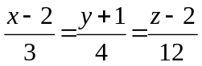 and the plane x-y+z =5 | 8
 | b. | Find the equation of the sphere through (1,0,0),(0,1,0),(0,0,1) and its centre lies on plane x+y+z-6=0. | 7
2. | a. | Find the extreme value of x² + y² + z² when 1/x + 1/y +1/z = 1. | 7
 | b. | State Euler's theorem for homogeneous function of three variables of degree n. If u = log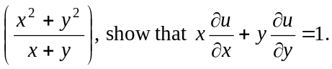 | 8
3. | a. | Sketch the region of integration and evaluate by interchanging the order of integration 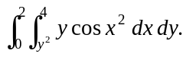 | 7
 | b. | Find the volume bounded by the xy- plane, the cylinder x²+y² =1and the plane x+y+z =3. | 8
4. | a. | Define order and degree of differential equations with suitable examples. Solve 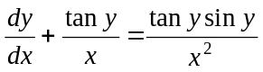 | 8
 | b. | Solve : 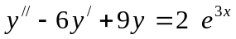 | 7
5. | a. | Solve by power series method y" +9y = 0. | 7
 | b. | Solve the following initial value problem  y" + y' – 2y = 0, y(0) = 4, y' (0) = 1. | 8
6. | a. | Define Laplace transform of any function. Find  ( i ) L (t² coswt)  ii) 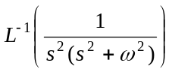 | 8
 | b. | Using the method of Laplace transform, Solve | 7
7.
 | a. | Find Center and radius of a sphere x² + y² + z² + 4x - 6y + 8z = 10. | 2
 | b. | Find integrating factor of ( xy³ + y) dx + 2( x² y² + x + y⁴) dy =0 | 2
 | c. | Find Laplace transform of f(t) = | 2
 | d. | If f(x,y,z) = + + , then show that x + y z = 0. | 2
 | e. | Solve 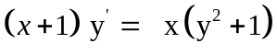 | 2

